**LAUNCH OF THE MONTPELLIER REPORT**

**Sustainable Intensification: A New Paradigm for African Agriculture**

*European Commission, Building Breydel2, Avenue d'Auderghem 19, 1000 Brussels,*

*28th May 2013, 14h30-16h30, Auditorium Room*

**Event jointly hosted by the European Commission and** [**CTA**](http://www.cta.int/)

Today, the world is searching for solutions to a series of global challenges unprecedented in their scale and complexity--food insecurity, malnutrition, climate change, rural poverty and environmental degradation . Sub-Saharan Africa is particularly vulnerable, with both supply and demand challenges putting pressure on an already fragile food system.

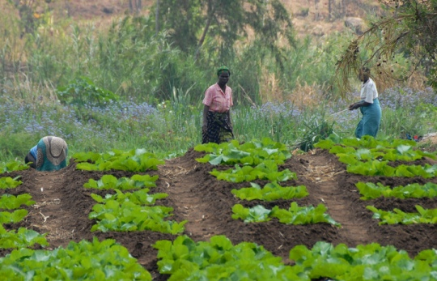In recent years, the term “Sustainable Intensification” – producing more outputs with more efficient use of all inputs on a durable basis, while reducing environmental damage and building resilience, natural capital and the flow of environmental services – has come to take on a highly charged and politicised meaning, becoming synonymous with big, industrial agriculture. As we strive to feed a population expected to reach nine billion by 2050 sustainably, the risk is that we may lose sight of the term’s scientific value and its potential relevance to all types of agricultural systems, including for smallholder farmers in Africa.

The Montpellier report provides innovative thinking and examples of the way in which the techniques of Sustainable Intensification are being used by smallholder farmers in Africa to address the continent’s food and nutrition crisis. It begins by examining the process and elements of intensification itself, before considering how we ensure that the intensification is sustainable, and concludes with practical solutions being practised today across the African continent, that underline the positive impacts the approach can produce if scaled up effectively.

__________________

**Event Programme**

14:30-14:45 **Introduction: Michael Hailu**, Director, CTA

**Jean-Pierre Halkin** (Co-chair), Head of Unit, Rural Development, Food Security & Nutrition, DG for Development and Cooperation, EuropeAid, European Commission

**Presentations from speakers**

The Montpellier panel members will present the report. The Ambassadors from Malawi and Burkina Faso will respond by bringing the perspective from their country and region.

14:45-14:55 **David Radcliffe,** Montpellier Panel member and Senior Advisor, Agricultural Research for Development, DG Development and Cooperation, European Commission

14:55-15:05 **Peter Hazell,** Montpellier Panel member and Visiting Professor, Imperial College London

15:05-15:15 **Tom Arnold,** Montpellier Panel member, former CEO of Concern Worldwide, Chair of the Convention of the Irish Constitution

15:15-15:25 **H.E. BraveR. Ndisale***,*Ambassadorof Malawi

15:25-15:35 **H.E. Frédéric Assomption Korsaga**, Ambassador of Burkina Faso

15:35-16:15 Q & A Session moderated by **Michael Hailu**, Director, CTA

**Conclusion**

16:15-16:30 [**Yemi Akinbamijo**](http://www.sri-executive.com/announcements) (Co-Chair)**,** Executive Director, Forum for Agricultural Research in Africa (FARA).